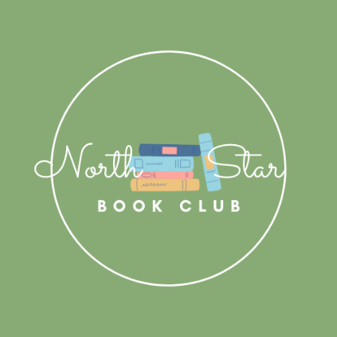

NorthStar Book Club

High School students, are you looking to meet new people and build a community? do you like to read? Join the NorthStar Book Club! Every month we will choose a book to read and discuss it together at the end of every month.

This month’s novel: The Book Thief by Markus Zusak

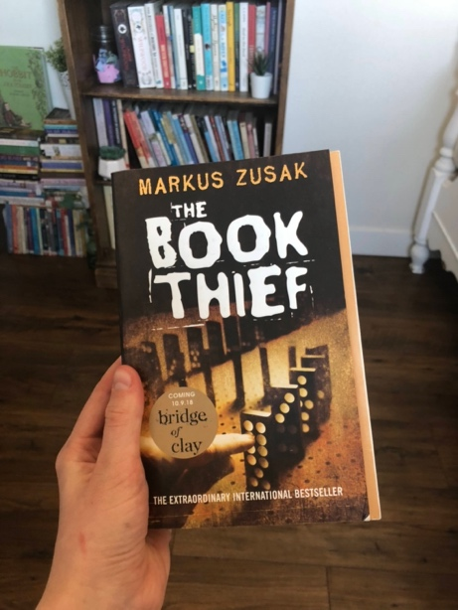

To join click the link:
https://discord.gg/v5wSCxgZ

