How to clear you cache on your computer NOTE** Make sure you save all your passwords on a piece of paper
Go to GOOGLE CHROME and click on the following highlighted lines in the top right hand corner of your screen.
You will see a drop down menu come up. Click on HISTORY.
Now click on
You will now see the following page:
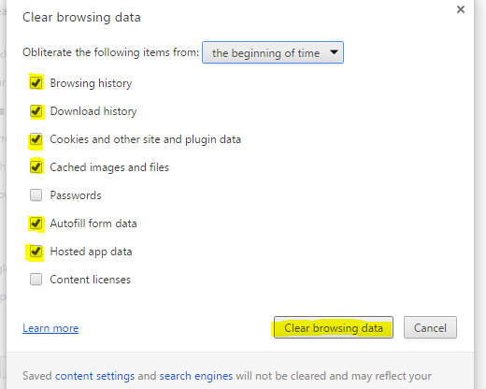
Click all the highlighted checkboxes and then click on CLEAR BROWSING DATA.
This should clear you caches.

