Geography Fair
Jan 27, 2015
Bethel Pentecostal Church, Edson, AB

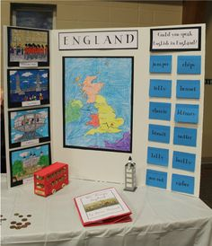
Purpose/Benefits of participating (courtesy of GeographyFair.com)
- Gain a better international understanding
- Improve research skills such as library and Internet use
- Develop presentation skills
- Sharpen writing skills
- Develop time management skills
- Develop multi-cultural sensitivities
- Gain an understanding of the relationship between humans and the environment
- Study specific topics of interest
- Learn geography in interesting and exciting ways

Process: This can be done individually or in groups of 2-3
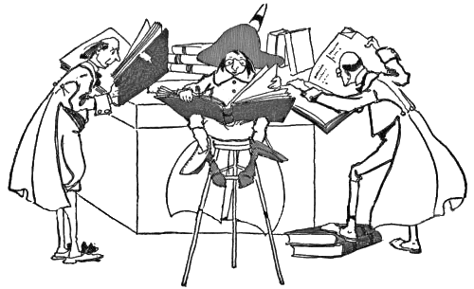
Step 1: Do research using your local library, curriculum or internet. Gather information about your countries population, economy, religions, environmental situation, cultural practices and dress, flag, food etc.

Step 2: Create a display to share the gathered information.
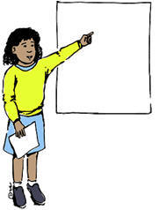

Step 3: Prepare a presentation to share on the day of the fair. This presentation should be 3-5 minutes long and can include cultural dance, poetry, song, report, painting (art). Make sure to practice and know who is speaking and when!

Step 4: Find and prepare a traditional dish from your country to share as part of a potluck meal at the end of the fair.

We would like to encourage you to choose a country you are studying in Social Studies.

Planning Sheet: Please submit to Mrs. Luymes by Jan 8, 2016
Name: ________________________________
Country I/we have chosen: _________________________________
Food/Recipe for potluck (from country studied):____________________________________
Presentation Planning
Brief Research Notes (including important/interesting topics to cover)
Resources I/we plan on using

