How to forward Gmail/myghsd.ca email to another account.

- Log into the Golden Hills Learning Commons website or your School Learning Commons:
  - Lc.myghsd.ca
  - Ghla.myghsd.ca
  - Nsa.myghsd.ca
- After logging in click on your Gmail link.
- Once in Gmail click on down arrow next to the settings. (looks like a gear)
  - 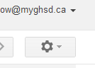
- In the drop down list choose settings and then click on the “Forwarding” tab
  - 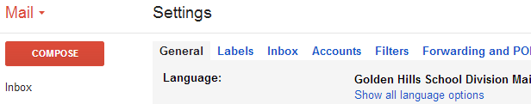
- Click on “Add a forwarding address”, fill in the new email address and click on next. Click on “Confirm”. Click on “Proceed”. This will send a confirmation email to the forwarding address. Log into your other email address and follow the instructions in the confirmation email.
- Log Back into your Gmail account and check “Forward a copy of incoming email to”. Click the drop down list and chose the email to forward to. The second drop down list allows you determine what to do with the Gmail/myghsd.ca
- Click “Save Changes” at the bottom of the page.
