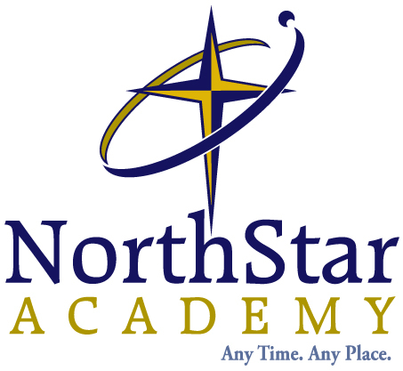
Newsletter
May – June edition
Rene Hoeksema and Susan Sampson
This month it is my turn to do the newsletter. Actually, it was my turn to do it last month, but even though I left myself a sticky note, I forgot to look at the note. So this month I will do it with Susan Sampson since it is her turn this month.

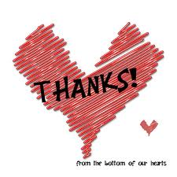
I would like to start by thanking the office staff that keeps everything running smoothly here at NorthStar. To the right is a picture of Emily who answers the phone (and does a bunch of other things). She has helped me greatly this year and I want to thank her for that. The rest of the office staff is also fantastic. Maybe you have noticed that NorthStar has grown by leaps and bounds and we have the office staff to thank for that. So this is for all of you in the office!! Without their help and support it would be impossible for us teachers to do our job!!
Next year we are switching to Moodle and that will be a whole different way of doing things. It will be a learning curve for all of us, but I think that it will be a whole lot better. That reminds me of a joke. I am Dutch and I know how true this is:
How many Dutchman does it take to change a light bulb? None since we do NOT like change.

In spite of that, I am excited about the change to Moodle. From what I have seen, it will be a lot better for us, the teachers, and for you, the parents and students, and I for one am really hoping that it is possible for an old dog to learn new tricks.

The end of the school year is almost upon us now. There are only a few days left to get your work in. Do your best to get in as much work as you can since we, as teachers, want very much to give you the best mark that we possibly can. This was a terrific year for me. I remember when we started this year last August that it seemed like it would be a long time for us to come to the end and now here it is. It has been great getting to know new students and continuing on with the old ones. Just a reminder: if you want to take summer courses it is now time to sign up. Please email the office at office@nsaschool.ca for summer school registration forms. We hope that you will all be with us again next year, but if for some reason you will not be back, we wish you the best and all of God’s blessings. By the way, they come naturally when you belong to Him. There are two things that will never change:
- The Father loves you!!
- The father promises that whatever happens in your life will be used for your good!!
And that is all that you need to remember. This Bible verse is very important to me. It is only in the last ten years that I have come to understand exactly what this means.
I have been crucified with Christ and I no longer live, but Christ lives in me. The life I now live in the body, I live by faith in the Son of God, who loved me and gave himself for me Galatians 2:20

NSA Graduation 2013
An excerpt from teacher Corrie Leismeister’s address to our graduating class of 2013:
“Follow your dreams! Make goals! Execute plans! And if you’re wondering, “How do I know what to do? What if I make a mistake?” Remember Phil. 2:13 for it is God who works in you to will and to act in order to fulfill his good purpose. – remember that God, who lives right inside you, in his Holy Spirit is leading and guiding you as long as you continue to seek him. Sometimes things will not work out the way you think they will. In fact, they rarely do! But whether in trial or triumph, know that God is working, and things will always change. “



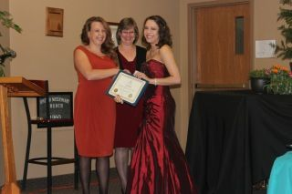


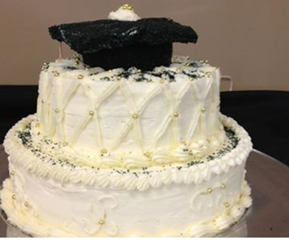

Cake made by NSA grad Marie Onishenko. She will be attending culinary school at NAIT in September.
An excerpt from principal, Kimberley Brown’s address to the grads at the NSA graduation ceremony, Saturday, June 8th, 2013.


“Young people, I challenge you today as Paul challenged young Timothy, to be an example for Christ. Be an example in speech. In Colossians 3, Paul tells us to rid ourselves of bad language and put downs. Christian young people, we must use our words to glorify our God—to build others up, to encourage and affirm one another. That is setting an example in speech.
I challenge you to be an example in life. I love words of Psalm 63: "because your love is better than life, my lips will glorify you. I will praise you as long as I live, and in your name I will lift up my hands."

I challenge you to be an example in love. I find it interesting that when Jesus was asked which of all the commandments was greatest his response was "to love the Lord your God will all your heart and soul and mind and strength and to love your neighbor as you love yourself." Now without minimizing the amount of knowledge you’ve attained in your years at NSA, Jesus isn’t telling us to love the Lord your God with all your mind and all your mind and all your mind and all your mind. That’s what the Pharisees did. It’s not about what’s between our ears. We need to love God with all our heart and soul and mind and strength. Be an example in love.
I challenge you to be an example in faith. Romans 10, verse 9 says, "If you confess with your mouth that Jesus is Lord and believe in your heart that God raised him from the dead, you will be saved." If you truly believe that, you can’t help but be an example in faith.”
Summer Boredom Busters
- Around the World in 60 Days – Have you ever wondered what life is like in other countries? This summer, Thriving Family invites you to join on a trip around the world, exploring 27 different countries on six continents. For each day of the trip, they’ve packed a biblical lesson and an activity that will give your family a glimpse into another culture. http://www.thrivingfamily.ca/Features/Magazine/2013/around-the-world-in-60-days.aspx

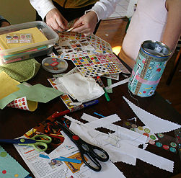
- Time Capsule – Gather up today’s memorabilia and tuck them away. Large cans with lids make good humidity-proof containers for storing a favourite comic or a best friend’s letter. What about putting in a child’s story, drawing or math test he or she is proud of. Make a date to open up the capsule next summer.


- Summer Reading Clubs – Most town/city libraries will have a summer reading club. Often these clubs offer activities and incentives for summer reading. If you don’t have access to one in your town, here is an online summer reading club: http://tdsummerreadingclub.ca/.

- If you live close to a Home Depot, they offer various workshops for kids. Two that are upcoming are:

http://www.homedepot.ca/workshops/come-out-and-play-with-the-fun-of-despicable-me-2
http://www.homedepot.ca/workshops/build-a-load-n-go-truck

- Michaels – If you live close to a Michaels store, they have Kids Club on Saturday mornings. Upcoming crafts include a Father’s Day Duck Tape Frame, Silly Shells, a Canada Day Hat, and Summer Games, Summer Bugs and Summer Totes. These classes are only $2.00 (materials included) and run Saturday mornings 10-12. Projects may vary depending on location, but you can download an activity calendar from here:
http://canada.michaels.com/on/demandware.store/Sites-MichaelsCanada-Site/default/Page-Show?cid=classes

- Thriving Family Summer Calendar Devos – Each Monday Thriving Family has a new family devotion. Topics include: God Has a Plan for Your Life, You Are Made Unique: Personalities and Abilities, You are Made Unique: Spiritual Gifts, God Wants to Use You Now, You Can Bless Others, and God’s Glory Can Shine Through You.
http://www.thrivingfamily.ca/extra/summer-calendar-devos.aspx
- Micah Road Mysteries Summer Boredom Busters – Check out this online resource for summer activities based on Biblical concepts. There are 9 boredom busters, including: Water Balloon Baseball, Milkshake Monopoly Marathon, Water Tag, and The Art of S’more.
http://www.gemsgc.org/MRM/?p=625
- Thriving Families Printable Boredom Buster Chart: http://www.thrivingfamily.ca/Family/Stages/Discovery%20Times/2012/www.thrivingfamily.com/~/media/Thriving/1-articles/2012/boredom-busters.pdf

Galatians 6:9

New International Version (NIV)
Let us not become weary in doing good, for at the proper time we will reap a harvest if we do not give up.


A Few Reminders:
*Textbooks need to be returned to the office upon completion of courses. BOOKS MUST BE RETURNED BY JULY 15TH (for online students).
*Registration is open. If you are planning on re-registering for the fall, please send in your forms as soon as possible.
*During the summer, the office will remain open Monday – Friday 9am – 4pm for textbook drop-off and pick-up or registration delivery.

It has been such a pleasure to work with each of our NSA families this year. We treasure each of you and look forward to working with you again in the fall. Blessings on the remainder of your school year and summer holiday!
Sincerely,
Rene Hoeksema and Susan Sampson (along with Sheila McIlwain, Teresa Learmont, Marci Penner, Corrie Leismeister, Shauna Crotser, Glenda Ferguson, Bobbie Luymes, Kimberley Brown, Michelle Best, Emily Christopherson)


